INTRODUCTION
In WLANs, the physical media, which is shared by all stations and has limited connection range, has significant differences when compared to wired media. The design of WLAN MAC protocol is further complicated by the presence of hidden terminal and capture effects. Currently, the IEEE 802.11 WLAN standards include a basic medium access protocol Distributed Coordination Function (DCF) and an optional Point Coordination Function (PCF).

INTRODUCTION
The channel access for the STAs in a BSS is under the control of a coordination function. The 802.11 MAC protocol provides two coordination functions: Distributed Coordination Function (DCF) and Point Coordination Function (PCF). The DCF is a contention-based access scheme using Carrier Sense Multiple Access with Collision Avoidance (CSMA/CA). The carrier sensing can be performed both at the physical layer and at the MAC sublayer. Priority levels for access to the channel are provided through the use of Interframe Spaces such as SIFS and DIFS. The backoff procedure is used for collision avoidance, where each STA waits for a backoff time (a random time interval in units of slot times) before each frame transmission. The PCF provides contention-free frame transmission in an infrastructure network by using the Point Coordinator (PC), operating at the access point (AP), to determine which STA currently gets the channel access. The DCF and the PCF can coexist by alternating the Contention Period (CP), during which the DCF is performed, and the Contention-Free Period (CFP), during which the PCF is performed. A CFP and a CP are together referred to as a CFP Repetition Interval or a Superframe.

DCF
In 802.11 DCF, a node starts its transmission if the medium is sensed to be idle for an interval larger than the distributed interframe space (DIFS). If the medium is busy, the node will defer its transmission until a DIFS is detected and then generate a random backoff period (backoff timer) before retransmission. The backoff timer will be decreased as long as the channel is sensed idle, frozen when the channel is sensed busy, and resumed when the channel is sensed idle again for more than a DIFS. A node can initiate a transmission when the backoff timer reaches zero. The backoff timer is uniformly chosen in the range [0,CW). CW is known as contention window, which is an integer with the range determined by the PHY characteristics CW_{min} and CW_{max} . After each unsuccessful transmission, CW will be doubled until reaching the maximum value CW_{max}=2^{m} W-1 , where W equals to (CW_{min}+1) . After each successful transmission, CW will reset to the minimum value CW_{min} . In 802.11 DCF for the DSSS physical channel, CW_{min}=31 , CW _{max}=1023 , and m’=5.
802.11 DCF defines two channel-access modes: basic and request to send/clear to send (RTS/CTS) base access. In basic access mode [Fig. 1(a)], the destination node will wait for a SIFS interval immediately following the successful reception of the data frame and transmit a positive ACK back to the source node to indicate that the data packet has been received correctly. If the source node does not receive an ACK, the data frame is assumed to be lost and the source node will schedule the retransmission with the doubled CW for backoff timer. When the data frame is being transmitted, all the other nodes hearing the data frame adjust their network-allocation vector (NAV), which is used for virtual carrier sense at the MAC layer, correctly based on the duration field value in the data frame received. This includes the SIFS and ACK frame transmission time following the data frame.
In RTS/CTS-based access mode, nodes transmit data utilizing special short RTS and CTS frames prior to the transmission of an actual data frame in order to shorten the collided time interval. As shown in Fig. 1(b), the node that needs to transmit a packet issues a RTS frame. When the destination receives the RTS frame, it will transmit a CTS frame after the SIFS interval, immediately following the reception of the RTS frame. The source node is allowed to transmit its packet if and only if it receives the CTS correctly. At the same time, all the other nodes will update the NAVs based on the RTS from the source node and the CTS from the destination node, which helps to overcome the hidden terminal
problem. In fact, the node that is able to receive the CTS frames correctly can avoid collisions even when it is unable to sense the data transmissions from the source node. If a collision occurs with two or more RTS frames, less bandwidth is wasted as compared to the situation where larger data frames can collide in the basic access mode.
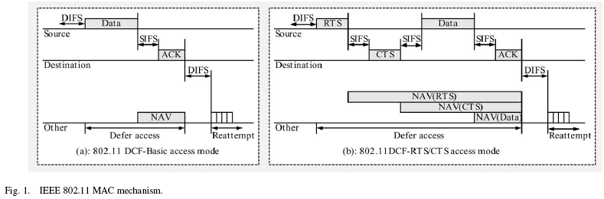

DCF
A station with a new packet to transmit monitors the channel activity. If the channel is idle for a period of time equal to a distributed interframe space (DIFS), the station transmits. Otherwise, if the channel is sensed busy (either immediately or during the DIFS), the station persists to monitor the channel until it is measured idle for a DIFS. At this point, the station generates a random backoff interval before transmitting (this is the Collision Avoidance feature of the protocol), to minimize the probability of collision with packets being transmitted by other stations. In addition, to avoid channel capture, a station must wait a random backoff time between two consecutive new packet transmissions, even if the medium is sensed idle in the DIFS time.
For efficiency reasons, DCF employs a discrete-time backoff scale. The time immediately following an idle DIFS is slotted, and a station is allowed to transmit only at the beginning of each slot time. The slot time size, , is set equal to the time needed at any station to detect the transmission of a packet from any other station. As shown in Table I, it depends on the physical layer, and it accounts for the propagation delay, for the time needed to switch from the receiving to the transmitting state (RX_TX_Turnaround_Time), and for the time to signal to the MAC layer the state of the channel (busy detect time).
DCF adopts an exponential backoff scheme. At each packet transmission, the backoff time is uniformly chosen in the range (0, w-1). The value w is called contention window, and depends on the number of transmissions failed for the packet. At the first transmission attempt, w is set equal to a value CW_{min} called minimum contention window. After each unsuccessful transmission, w is doubled, up to a maximum value CW_{max} = 2^{m} CW_{min}. The values CW_{max} and CW_{min} reported in the final version of the standard are PHY-specific and are summarized in Table I.
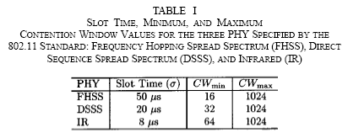
The backoff time counter is decremented as long as the channel is sensed idle, “frozen” when a transmission is detected on the channel, and reactivated when the channel is sensed idle again for more than a DIFS. The station transmits when the backoff time reaches zero.
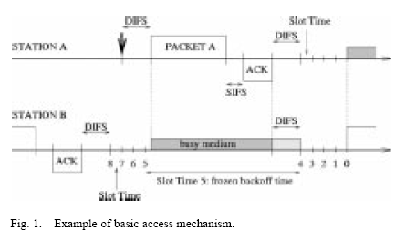
Fig. 1 illustrates this operation. Two stations A and B share the same wireless channel. At the end of the packet transmission, station B waits for a DIFS and then chooses a backoff time equal to 8, before transmitting the next packet. We assume that the first packet of station A arrives at the time indicated with an arrow in the figure. After a DIFS, the packet is transmitted. Note that the transmission of packet A occurs in the middle of the Slot Time corresponding to a backoff value, for station B, equal to 5. As a consequence of the channel sensed busy, the backoff time is frozen to its value 5, and the backoff counter decrements again only when the channel is sensed idle for a DIFS.
Since the CSMA/CA does not rely on the capability of the stations to detect a collision by hearing their own transmission, an ACK is transmitted by the destination station to signal the successful packet reception. The ACK is immediately transmitted at the end of the packet, after a period of time called short interframe space (SIFS). As the SIFS (plus the propagation delay) is shorter than a DIFS, no other station is able to detect the channel idle for a DIFS until the end of the ACK. If the transmitting station does not receive the ACK within a specified ACK_Timeout, or it detects the transmission of a different packet on the channel, it reschedules the packet transmission according to the given backoff rules.
The above described two-way handshaking technique for the packet transmission is called basic access mechanism. DCF defines an additional four-way handshaking technique to be optionally used for a packet transmission. This mechanism, known with the name RTS/CTS, is shown in Fig. 2. A station that wants to transmit a packet, waits until the channel is sensed idle for a DIFS, follows the backoff rules explained above, and then, instead of the packet, preliminarily transmits a special short frame called request to send (RTS). When the receiving station detects an RTS frame, it responds, after a SIFS, with a clear to send (CTS) frame. The transmitting station is allowed to transmit its packet only if the CTS frame is correctly received. The frames RTS and CTS carry the information of the length of the packet to be transmitted. This information can be read by any listening station, which is then able to update a network allocation vector (NAV) containing the information of the period of time in which the channel will remain busy. Therefore, when a station is hidden from either the transmitting or the receiving station, by detecting just one frame among the RTS and CTS frames, it can suitably delay further transmission, and thus avoid collision.
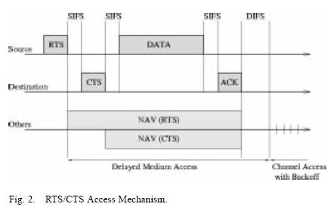
The RTS/CTS mechanism is very effective in terms of system performance, especially when large packets are considered, as it reduces the length of the frames involved in the contention process. In fact, in the assumption of perfect channel sensing by every station, collision may occur only when two (or more) packets are transmitted within the same slot time. If both transmitting stations employ the RTS/CTS mechanism, collision occurs only on the RTS frames, and it is early detected by the transmitting stations by the lack of CTS responses.

PCF
PCF access method is derived from the classical Time Division Multiplexing (TDM) technique. The point coordinator works as a master and stations work as slaves. In PCF mode, the transmission time is spliced into poll slots for stations. Stations are allowed to send data only when they receive the polling frames from the point coordinator. Each station can transmit one data frame upon receiving a polling frame. The point coordinator, which shall reside at the access point, determines which station should be polled for data transmissions. Without the uncertain delay caused by collisions, PCF provides bounded delay and is suitable for transmitting data generated by intolerant applications and tolerant applications, like audio, video, etc. PCF is above DCF in the sense that PCF needs to understand the frames emitted by stations in DCF mode. PCF is only for the infrastructure configuration and is optional for the access point, which decides whether PCF mode is enabled or not. Even if the access point enables the PCF mode, the stations still can decide whether they want to be polled or not.
If the DCF mode and PCF mode coexist at the access point, transmission slots are divided into Contention Free Period (CFP, for PCF mode) and Contention Period (CP, for DCF mode). CFP and CP appear alternately. The CFP duration is constrained by CFPMaxDuration, a MIB parameter, while the CFP frequency is defined by CFPRate, another MIB parameter, as shown in figure 2.
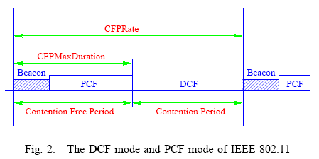
Only the stations in the polling list maintained by the point coordinator are eligible to receive polls. When a station joins a BSS, it can ask to be appended to the polling list by sending the Association Request frame with the CF Pollable subfield set to be TRUE. If a station is not in the polling list at the beginning, it also can send ReAssociation Request frame to do that. If a station is in the polling list initially but it doesn’t want to be polled late, it can send ReAssociation Request frame to the point coordinator. Accordingly, the point coordinator will remove the station from the polling list.

PCF
To support time-bounded services, the IEEE 802.11 standard defines the Point Coordination Function (PCF) to let stations have priority access to the wireless medium, coordinated by a station called Point Coordinator (PC). The PCF has higher priority than the DCF, because it may start transmissions after a shorter duration than DIFS; this time space is called PCF Interframe Space (PIFS), which is 25 us for 802.11a and longer than SIFS, i.e., the shortest inter-frame-space. Time is always divided into repeated periods, called superframes. With PCF, a Contention Free Period (CFP) and a Contention Period (CP) alternate over time, in which a CFP and the following CP form a superframe. During the CFP, the PCF is used for accessing the medium, while the DCF is used during the CP. It is mandatory that a superframe includes a CP of a minimum length that allows at least one MSDU Delivery under DCF.
A superframe starts with a so-called beacon frame, regardless if PCF is active or not. The beacon frame is a management frame that maintains the synchronization of the local timers in the stations and delivers protocol related parameters. The PC, which is typically collocated with the AP, generates beacon frames at regular beacon frame intervals, thus every station knows when the next beacon frame will arrive; this time is called target beacon transition time (TBTT) and is announced in every beacon frame. Note that the beacon frame is required in pure DCF even if there is only contending traffic. There is no contention between stations; rather, stations are polled. See Fig. 2 for a typical sequence during CFP. The PC polls a station asking for a pending frame. Because the PC itself has pending data for this station, it uses a combined date and poll frame by piggybacking the CF-Poll frame on the data frame.
Upon being polled, along with data, the polled station acknowledges the successful reception. If the PC received no response from a polled station after waiting for PIFS, it polls the next station, or ends the CFP. Thus no idle period longer than PIFS occurs during CFP. The PC continues with polling other stations until the CFP expires. A specific control frame, called CF-End, is transmitted by the PC as the last frame within the CFP to signal the end of the CFP.
