INTRODUCTION
There has been a rapid growth in the deployment of wireless networks in the past few years. Compared with their wired counterparts, wireless networks allow their users to be mobile, while yet continuing to access computing services. Recently, wireless networks based on the IEEE 802.11 standard have gained popularity in providing wireless connectivity to mobile stations.
The IEEE 802.11 standard defines two modes of operation to provide connectivity to mobile stations:
• An infrastructural mode, where mobile stations are wirelessly connected to a wired network via an access point that acts as a gateway between the wired network and the mobile stations (i.e., the wireless end-points). In the remainder of this paper, we focus only on the infrastructural mode of operation.
• An infrastructure-less ad-hoc mode, where mobile stations do not require the presence of an access-point, and form a network by directly communicating, and co-ordinating, with each other to forward messages through the system.
Each access-point has a coverage area, i.e., a limited range of operation, which is typically 500-1500 feet in an open environment; mobile stations operating within an access-point’s coverage area are capable of receiving signals from that access-point. Multiple access-points are typically installed in order to provide seamless, continuous connectivity to mobile stations as they move from one location
to another. The IEEE 802.11 standard, therefore, provides for a handoff mechanism, in order to support the transfer of a mobile station from one access-point to another, as the station moves between the respective coverage areas of the two access-points. The access-point, together with the mobile stations associated with it, form a basic service set (BSS). The collection of BSSs connected by a wired network (also called a distribution system) is known as an extended service set (ESS). Figure 1 shows an 802.11 wireless system consisting of two basic service sets (BSS1 and BSS2) connected by a wired network to form an extended service set (ESS).
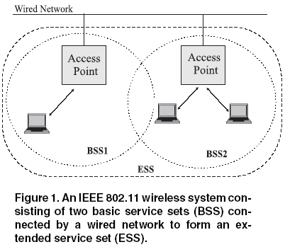

INTRODUCTION
IEEE 802.11 based wireless local area networks (WLANs) have seen immense growth in the last few years. The predicted deployment of these networks for the next decade resembles that of the Internet during the early 90s. In public places such as campus and corporations, WLAN provides not only convenient network connectivity but also a high speed link up to 11 Mbps (802.11b).
The IEEE 802.11 network MAC specification allows for two operating modes namely, the ad hoc and the infrastructure mode. In the ad hoc mode, two or more wireless stations (STAs) recognize each other and establish a peer to peer communication without any existing infrastructure, whereas in infrastructure mode there is a fixed entity called an access point (AP) that bridges all data between the mobile stations associated to it. An AP and associated mobile stations form a Basic Service Set (BSS) communicating in the unlicensed RF spectrum.
A collection of APs (connected through a distribution system DS) can extend a BSS into an Extended Service Set (ESS refer figure 1).
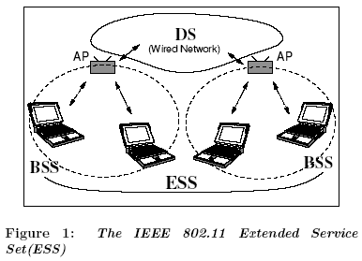

Association in WLAN
This subsection describes in detail the association procedure in WLAN. It is essential to understand this procedure because it specifies the way a station discovers APs in range and the criteria for selecting a particular AP when several are available.
A station must be associated with an AP in order to send or receive data frames. The association procedure is always initiated by the station (mobile-controlled handover) and a station can only be associated with one AP. In the considered scenario, (see Figure 3) when a station powers on, it must discover which APs are present and then requests to establish an association with a particular AP. Thus, first the station initiates a scanning process that can be either active or passive:
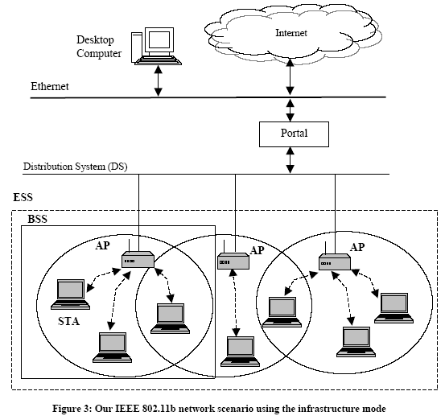
1. Passive scanning: in this case the station waits to receive a beacon frame from the AP. The beacon frame is a frame sent by the AP periodically (with a typical period of 100 ms) with synchronization information. The beacon contains information corresponding to the BSS such as ESS ID, beacon interval, capabilities and traffic indication map (TIM).
2. Active scanning: the station tries to find an AP by transmitting Probe Request Frames, and waiting for Probe Response from the APs.
These two methods are valid, and either one can be chosen according to the power consumption/ performance trade-off. Once the scanning process has finished, the station has an updated list of APs in range. This information is used by the station to associate with the AP that provided a higher Signal-to-Noise Ratio (SNR).
At this point, the station sends an Authentication Request to the selected AP (assuming that the default association method, Open System Authentication, is used). Upon the reception of this notification, the AP answers sending an Authentication Response to the station. If the status value of this response is “successful”, the station is now authenticated with the AP and sends an Association Request message to it. Upon the reception of this message, the AP sends an Association Response to the station. If this second response was also successful (the response could be negative if, for example, the particular MAC address of that station was not allowed to communicate through that AP), the station is authenticated and associated with the AP.

Handoff Mechanism in 802.11 Wireless Networks
The handoff process refers to the sequence of steps followed jointly by the mobile station and the access-point in transferring the link-level connectivity from one access-point to another. The IEEE 802.11 standard allows mobile stations to be handed over from one access-point to another, when a
station moves between the coverage areas of the two access points. However, before a mobile station can be handed over to a new access-point, the mobile station should be able to discover the new access-point. The IEEE 802.11 standard allows two modes by which a mobile station can detect the presence of an access-point
- Passive Scanning - In this mode, a mobile station sweeps from channel-to-channel (the 802.11 standard defines 13 channels of 5MHz each) to detect the presence of Beacon frames which are periodically transmitted by the access-points. The Beacon frames contain all the information that is needed by a mobile station to associate itself with the access-point. A mobile station can establish the presence of an access-point on a channel if it is able to detect a Beacon frame on that channel. The advantage of passive scanning is that the mobile station saves battery power because it does not have to transmit anything.
- Active Scanning - In this mode, a mobile station actively seeks out access-points by broadcasting Probe Request frames on every channel. An access-point that receives a Probe Request frame responds to the client by sending the Probe Response frame. The mobile station can establish the existence of an access-point on a channel if it receives the Probe Response frame on that channel.
Once a mobile station has discovered access-points in an area, it has to chose an access-point with which to associate. The IEEE 802.11 mandates that a mobile station be associated with only one access-point at a given time. This allows the switches in the wired network to forward the messages
meant for a mobile station only to the access-point that the mobile station is associated with. Before a mobile station can be associated with an access point, it has to authenticate itself to the access-point. After the access-point sends an acknowledgment verifying the mobile station’s identity, the mobile station sends a re-association request to the new access-point. The mobile station is considered to be associated with the new access-point only after it receives a re-association response from the new access-point. The total latency in the entire handoff process is the sum of the delay in the scanning process to detect an access-point, and the delay in authenticating and re-associating the mobile station with the new access-point.

HANDOFF IN WIRELESS LANS
In this section, we give a brief overview of how handoff works in WLANs, in particular, we describe the handoff mechanism employed by IEEE 802.11 that is the de-facto wireless LAN standard. 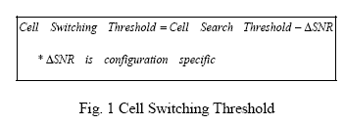
When a mobile unit moves away from its access point, the Signal-to-Noise (SNR) of the link drops, and will eventually drop below a certain threshold value known as the cell search threshold. This event triggers the roaming algorithm to start looking for other access points to associate with. In this process, the mobile node initiates a sweeping that performs a series of scans on different frequencies to construct an updated access point list. When the SNR drops below a second threshold known as cell switching threshold (and defined by the equation shown in Fig. 1), the roaming algorithm triggers a re-association by selecting another access point from the access point list. Typically, the access point with the strongest signal strength is selected. 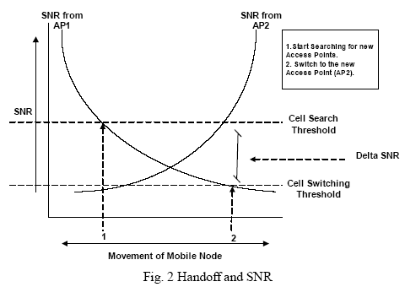
Fig.2 shows the relationship of the SNR of two access points as a mobile node roams from AP1 to AP2. When the mobile node selects an access point from the access point list, it sends an association request requesting to bind to that particular access point. Assuming that the mobile node is not denied access, the access point responds with an association response that in effect binds the mobile node to the access point. Fig. 3 illustrates that interaction sequence. 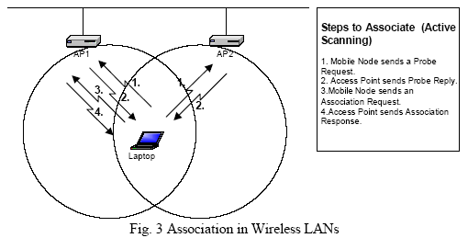
It is important to emphasize that roaming is not the only mechanism that triggers handoffs. More specifically, access points can be configured to use a particular load-balancing algorithm that initiates handoffs when the load becomes uneven across multiple overlapping cells. However, irrespective of what triggers handoffs, they typically rely on physical and MAC layers characteristics.

