BUILT-IN 802.11B SECURITY MEASURES
Anyone within range of the Access Point radio can potentially eavesdrop on WLAN traffic or use the Access Point to access any connected network. In fact, unauthorized joyriders surf countless corporate networks and the Internet through unprotected Access Points; this is the point Shipley and Peterson were making with their demonstration. This isn’t to say that 802.11b networking is inherently without any built-in security features.
At the simplest level,802.11b enables two types of security: encryption (to preclude eavesdropping) and authentication (to prevent unauthorized users from accessing the network). When Shipley and Peterson were driving around Silicon Valley discovering unsecured WLANs, they also discovered failures of both types of security. Indeed, manufacturers typically ship 802.11b products with all the security
features disabled by default, so Shipley and Peterson’s findings were certainly not a surprise.
To associate with each other, Access Points and stations exchange various types of management frames, which are used to help determine who is allowed to join the network. For example, Access Points can periodically transmit beacon frames containing a unique identifier, known as a service set identifier (SSID), for the Basic Service Set. Stations use an SSID to gain access to a network, as described later.
Stations also transmit probe frames to discover Access Points. When a station finds an Access Point, it initiates an association and proposes an authentication method. The default association method, Open System Authentication, actually provides no authentication at all. In Open System Authentication, any station can join the BSS. The station can associate with any Access Point and “listen” to all data sent as plaintext. Network administrators usually implement this type of association when ease-of-use is the main issue or they’re not concerned with security.
It has been widely suggested that frequency-hopping WLAN systems (802.11b uses a spread-spectrum technology) would be less vulnerable to security attacks than other WLANs. This is not true; in frequency-hopping systems, Access Points transmit the hopping codes and timings in plaintext, which is easily available to an attacker
SSID
Administrators can implement network access control using an SSID associated with an Access Point or with a group of Access Points. The SSID provides a mechanism to segment a wireless network into multiple networks serviced by one or more Access Points. Each Access Point’s programming includes an SSID corresponding to a specific wireless network. The SSID is a unique string that identifies the network, but it is the same string for all users on the network. To access this network, a client computer’s configuration must include the correct SSID. A building might be segmented into multiple networks by floor or department. Typically, a client computer can use multiple SSIDs for users who require access to the network from various locations.
Because a client computer must present the correct SSID to access the Access Point, the SSID acts as a simple password and consequently provides some measure of security. However, this minimal security is compromised if, as is common, the administrator configures the Access Point to broadcast its SSID. With this broadcast feature enabled on a wireless network, any client computer not configured with a specific SSID can receive the SSID and gain entry to the Access Point.
Thus, the SSID actually provides virtually no security benefits at all hackers can easily sniff it in plaintext from every packet. So the SSID’s primary value is to partition traffic to a particular network.
MAC address filtering
Although an Access Point has an SSID for identification, a station uses the unique MAC address of its 802.11 network card as an identifier. To increase an 802.11 network’s security, you can program each Access Point with a list of MAC addresses associated with the client computers allowed to communicate through the Access Point. If a client’s MAC address is not on this list, the network does not let the client associate with the Access Point.
MAC address filtering provides stronger security than relying on SSIDs, but it comes with somewhat
cumbersome administrative overhead: Administrators must manually program each Access Point with a list of MAC addresses and keep the list current. The administrative overhead of provisioning individual Access Points—there is no open-standard method of sharing access lists among Access Points—limits this approach’s scalability. Thus MAC address filtering is best suited for small networks.
A determined hacker could identify and counterfeit the valid MAC addresses used on the network cards. After capturing an authorized MAC address, an intruder could easily program her own network card to have the same MAC address and gain access to the WLAN.
Wired Equivalent Privacy (WEP)
Network administrators can secure WLANs by employing techniques specified in the Wired Equivalent Privacy (WEP) standard. Its developers designed WEP so that 802.11 networks would have confidentiality similar to that of standard LANs. WEP uses an algorithm-based encoding system to protect wireless communication from eavesdropping. Most WEP implementations also authenticate stations seeking to join a BSS, thereby preventing unauthorized access to the WLAN.
In other words, when enabled, WEP encrypts the data portion of each packet exchanged between the station and the Access Point. It uses either a 40- or 128-bit encryption algorithm and relies on a secret key that the station and Access Point share. The station and Access Point use the secret key to encrypt packets before transmitting them. The receiver also uses an integrity check to ensure that packets remain unmodified in transit. The WEP standard does not specify how to establish the shared key. In practice, most implementations have all stations and Access Points share a single key.
In addition, some implementations use WEP in conjunction with the optional shared-key authentication
algorithm to prevent unauthorized devices from associating with an 802.11b network. If the station proposes shared-key authentication, the Access Point generates a random 128-bit challenge. The station returns the challenge, encrypted with a shared key—a secret configured into both the station and the Access Point. The Access Point decrypts the challenge using a CRC (cyclic redundancy checker) to verify its integrity. If the decrypted frame matches the original challenge, the Access Point considers the station authentic. The Access Point and station repeat the challenge/response handshake in the opposite direction for mutual authentication. It is perfectly reasonable to enable both the encryption and authentication features of WEP. Unfortunately, WEP uses the same shared key for encrypting/ decrypting data frames and for authenticating the station. It is a major risk to have both encryption and authentication keys be the same.
WEP security is also not available in ad hoc (or peer to peer) 802.11b networks that do not use Access Points. These networks would include, for example, a room full of laptop users who create a peering network using 802.11b. In this situation, the laptops connect to each other via their station transmitters but do not use an Access Point radio. The only security enabled on such a network would be whatever the laptop operating systems’ provided, which is usually minimal.
Short answer to WLAN security
Enabling all of the 802.11b security features collectively—SSID, MAC address filtering, and WEP—provides the most secure environment for WLAN traffic without having to resort to external measures. Figure 1 shows where these different features fit in such a network.
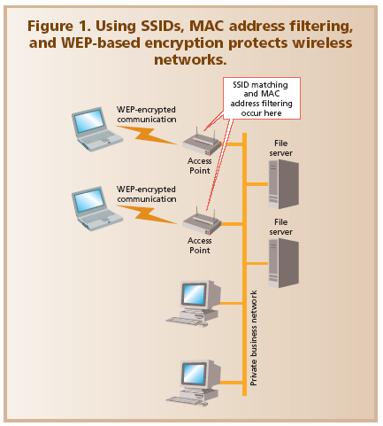
It is important to remember that physical security usually doesn’t prevent intruders from getting close to a WLAN, so you must proceed on the assumption that intruders can and will snoop WLAN traffic. If you implement only built-in 802.11b security measures, be prepared to accept the likelihood that a determined hacker will defeat the 802.11b security and use a WLAN Access Point to reach the corporate network.
So, 802.11b security measures will be a sufficiently effective deterrent for some casual networking environments. As with any networking environment, a competent security analysis is critical when deploying WLANs. However, it is highly unlikely that most enterprise computing environments will find the inherent 802.11b security measures sufficient.
A growing consensus among industry experts charges that corporate users are not using WEP at all or, if they are, they are doing an inadequate job of addressing overall security management.WEP, SSID, and MAC address filtering—even if inadequate against a determined hacker—are better than no security at all. At a minimum, these methods will collectively thwart the opportunistic or accidental hacker.

WEP Vulnerabilities
Currently, WEP is the security standard outlined for all 802.11 standards (see Figure 1); its goal is to secure WLANs at the same level as wired networks. WEP is based on the RC4 symmetric algorithm. Administrators deploy a secret key on both the access point and wireless devices, which use the key to encrypt data and check data integrity. In addition, the AP can use the key to authenticate its clients. Although RC4 algorithm’s overall cryptography is quite powerful, the WEP standard takes a poor approach to using it.
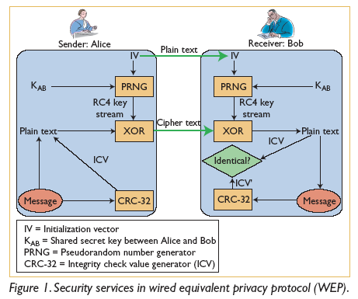
One of WEP’s biggest downfalls is that its secret keys (which wireless devices and their access points share) are relatively shorter than other security protocols’ keys — typically, 40 bits long in WEP, although the standard does allow up to 104-bit keys. WEP concatenates a shared secret key with a short 24-bit initialization vector (IV) to create the RC4 key stream. For instance, after WEP concatenates a 40-bit secret key with 24-bit IV, it generates a 64-bit RC4 key stream. The IV is sent to the receiver in plain text so that the receiver can generate the same key stream, which means that attackers can see the first 24 bits of every key sent using WEP. Furthermore, the fact that the IV is so short nearly guarantees that it will be used for multiple messages. In fact, the same IV might be reused in as little as half a day if there is significant activity over a company’s WLAN. An attacker could easily collect an IV and use it to retrieve the key that the AP and wireless devices use.
The current 802.11 standard has no guidelines for how, or even if, the IV should be changed. Some
vendors’ equipment actually uses the same IV for every key stream, which means an eavesdropper is guaranteed to uncover the IV. In response to widespread discussion of WEP’s flaws, other systems generated the IVs sequentially, incremented with the transmission of each packet.
WEP security also suffers from a poor solution for key management, which can leave the keys in a device unchanged for long periods of time. If the device were lost or stolen, an attacker could use the key to compromise not only that device but any other devices sharing the same key. Dynamic key management solutions could help mitigate the threat of WEP keys falling into the wrong hands, as well as increase complexity.
Further adding to the protocol’s shortcomings is WEP’s implementation of the Cyclic Redundancy Check (CRC)-32 algorithm, which calculates a 32-bit checksum to check the integrity of packets sent over the WLAN. Because the checksum that CRC-32 creates is a noncryptographic value, known attacks, such as side-channel attacks,10 can compromise the data’s integrity.

